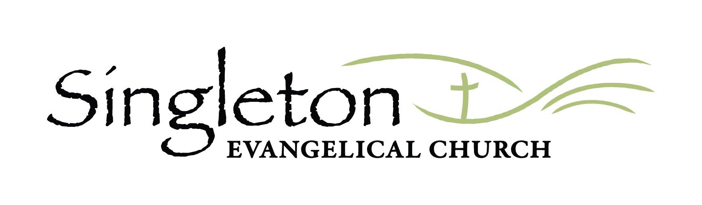
Please note that Singleton Alive 2023, will be held at Australian Christian College.
PERMISSION NOTE
Please fill in ONE Permission Note per family (i.e. If you are the parent of children from one family and a guardian of children from another family, you will be required to fill out this form twice).

(PLEASE PRINT AND ANSWER ALL QUESTIONS ON THIS FORM)
Childs Full Name | Year at School 2023 | Child full Name | Year at School 2023
*Children are Grouped according to their school year in 2023: *K-2 MINIS (M) *YR 3-5 KHAOS (K) *YR 6-12 ROCK (R)

Singleton Alive is an annual holiday program run in conjunction with Singleton Evangelical Church (SEC). All leaders are volunteers who have formally applied to be a part of the team and have undergone training to ensure a child-safe environment. They have also signed the “Working with Children” check and are in agreement with the Child Protection (Prohibited Employment) Act 1998.

In case of a Medical Emergency:
- I authorise the leader in charge of SEC or Singleton Alive to arrange for my child/ren to receive such first aid, medical or surgical treatment as the leader may deem necessary at any time during the program. You will be called as soon as possible if your child needs medical attention
- I authorise the use of ambulance and/or anaesthetic by a qualified medical practitioner if in his/her judgement it is necessary
- I accept responsibility for payment of all expenses associated with such treatment

General Agreement:
- I understand that photos of my children may be taken by the designated team photographer and that these photos may be published on the Singleton Alive or SEC social media pages.
- They may also be used in the making of a video clip of Singleton Alive for use in SEC Sunday services or SEC social media pages.
- If you do not want your child included in any such photos, please visit the registration desk to fill out the photo-exclusion sheet.

By signing here, you agree to the above & grant permission for your children to participate in the Singleton Alive 2023 program.

Full Name of Parent/Guardian (PLEASE PRINT):

Do you give permission for Singleton Evangelical Church to contact you by email regarding future Singleton Alive events?

Yes No

Parent/Guardian Signature: DATE: Contact Number:

